**Course code: CSC-283**

**Lab Report: 03**

**Submitted To**

Tanzina Tasnim Bithi

Department of Computer, Science and Engineering

**Submitted By**

Name: Md.Pranto Ali

ID: 23303101

Program: BCSE

Section: A

Semester: Fall 2024

Submission date: Teacher signature

1. **Calculate the factorial of a number:**

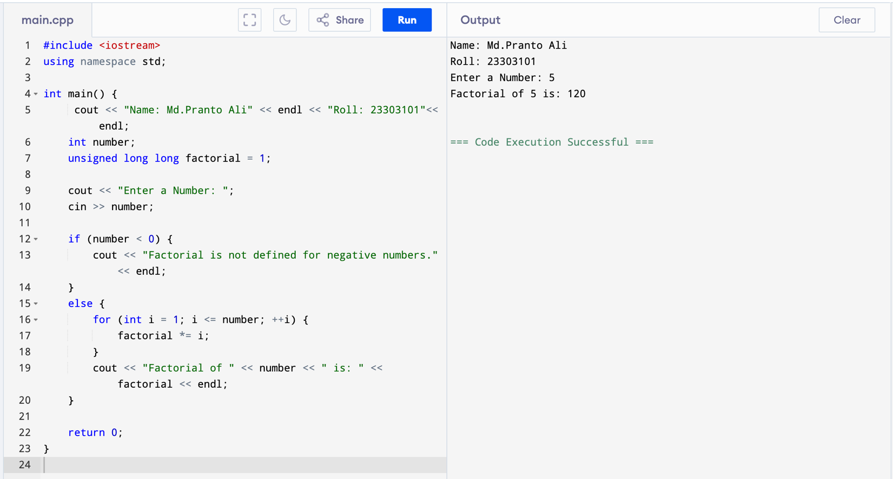

1. **Factorial of a number using recursion**
2. **Addition of two number Using function in c++**

1. Swaping two number using reference variable in function

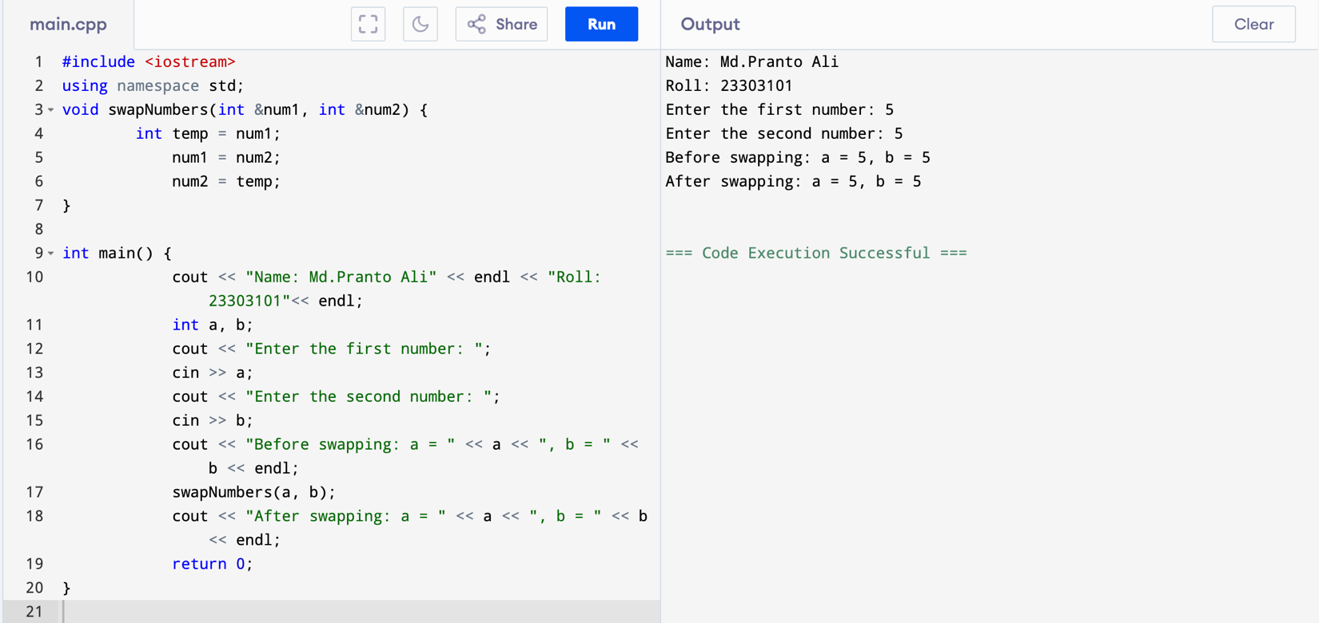

1. Swaping two number using Pointer in function

1. Cube a number using inline function

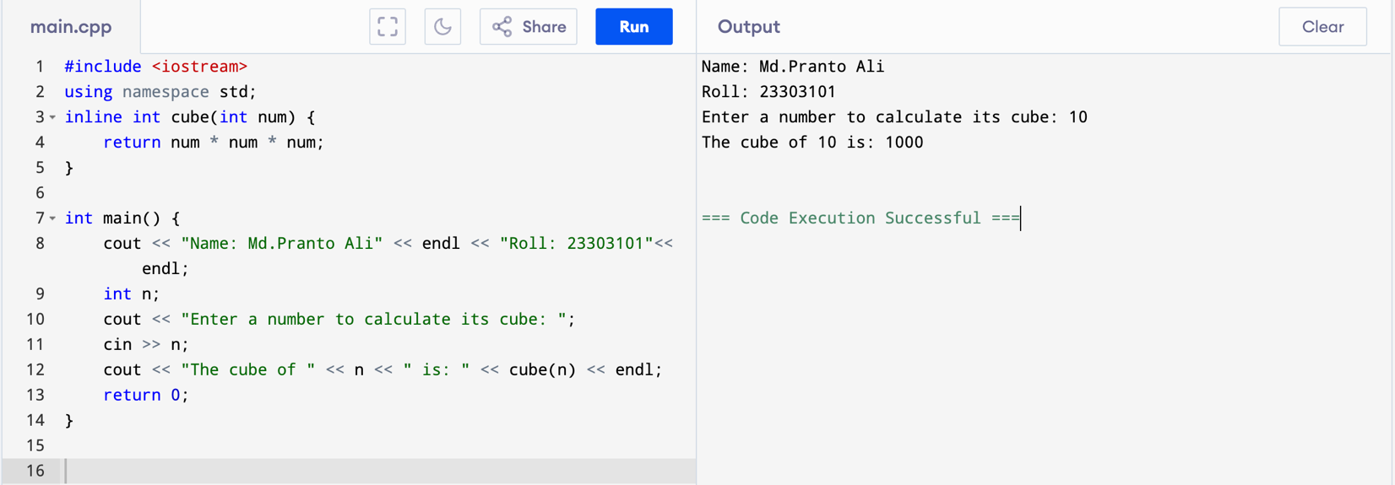

1. Sum of two number using recursion function

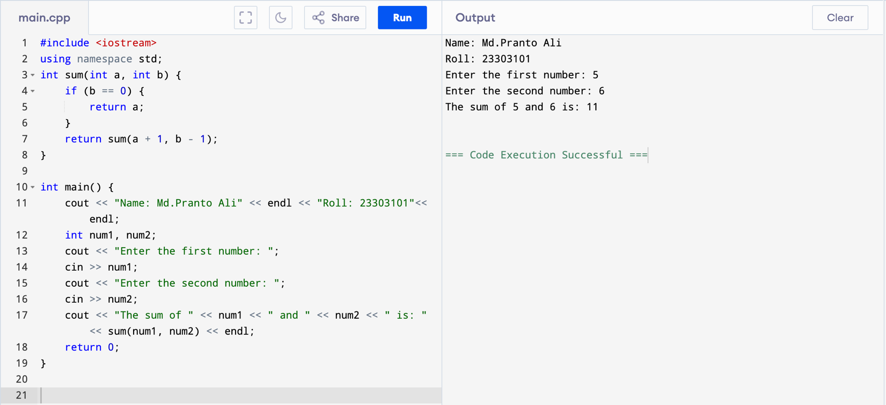

1. Default arguments in C++:

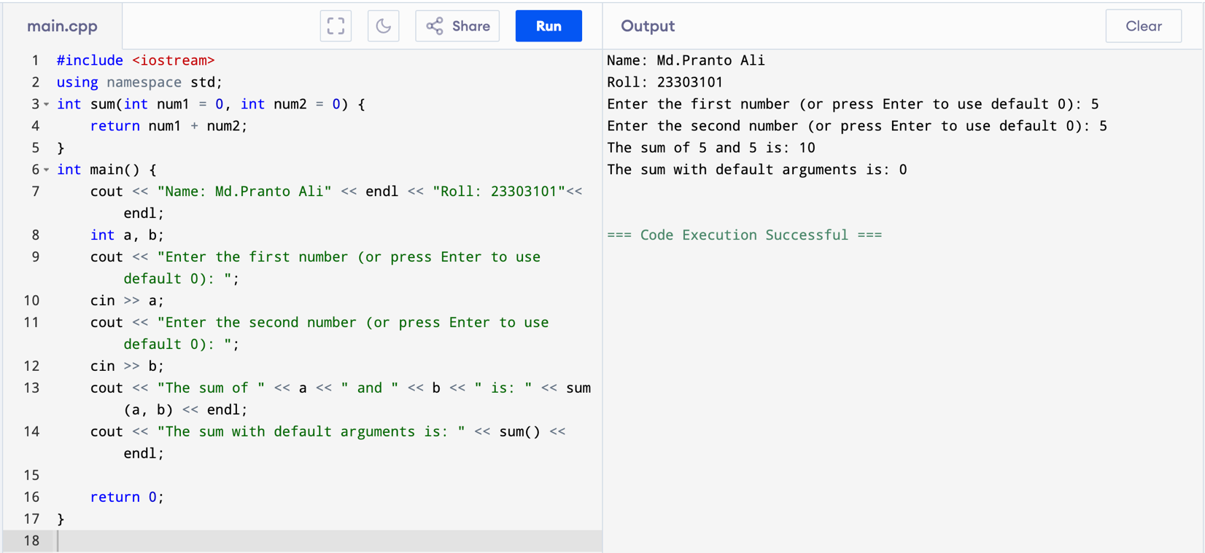

1. **Const arguments in C++:**

